Новикова А.А.

20-МИ

ИПТМ

1.Координатный формат

Схема хранения

|  |  |  |  |  |  |  |  |
| --- | --- | --- | --- | --- | --- | --- | --- |
| 1 | 2 | 3 | 4 | 5 | 6 | 7 | 8 |

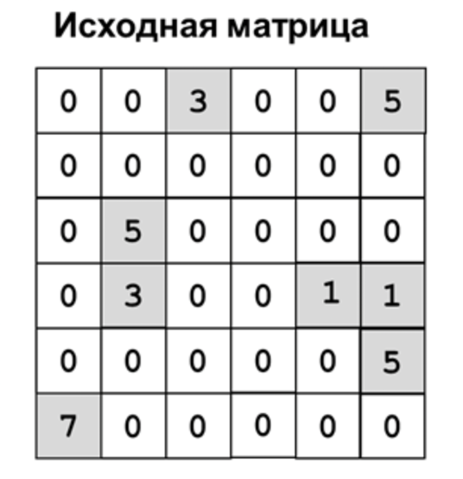

N

|  |  |  |  |  |  |  |  |
| --- | --- | --- | --- | --- | --- | --- | --- |
| 3 | 5 | 5 | 3 | 1 | 1 | 5 | 7 |

A

|  |  |  |  |  |  |  |  |
| --- | --- | --- | --- | --- | --- | --- | --- |
| 3 | 6 | 2 | 2 | 5 | 6 | 6 | 1 |

LJ

|  |  |  |  |  |  |  |  |
| --- | --- | --- | --- | --- | --- | --- | --- |
| 1 | 1 | 3 | 4 | 4 | 4 | 5 | 6 |

LI